LoRaWAN

Table of Contents

Target Audience 2

Critical Factors 4

Architecture 4

Device Classes 5

Advantages 6

**Long Range** (LoRa) is the physical layer or the wireless modulation used to create long range communication links. It is based on the **chirp spread spectrum**, which has the same low power characteristics as FSK modulation but significantly increases the communication range, to the extent of entire cities or hundreds of kilometres. Chirp spread spectrum has been used for decades in military and space communication, but LoRa is the first **low-cost implementation**.

The actual range of LoRa depends on the environment and the number of obstructions, but LoRaWAN has a **link budget** greater than any other standardized communication technology. The link budget, measured in dB, is the primary factor in determining range.

## Target Audience

We do not use the same technology everywhere. Wi-Fi and Bluetooth are fit for communication between personal devices. Mobile data is fit for devices that need a high data rate but work on a power source. **Low Power Wide Area Network** (LPWAN) is fit for devices that need to have a battery life of a few years, send data infrequently and in small amounts and transmit over long distances, over varying environments. This description fits **sensors**. LoRaWAN is an implementation of LPWAN.

The table below should clarify the differences between the three technologies mentioned here:

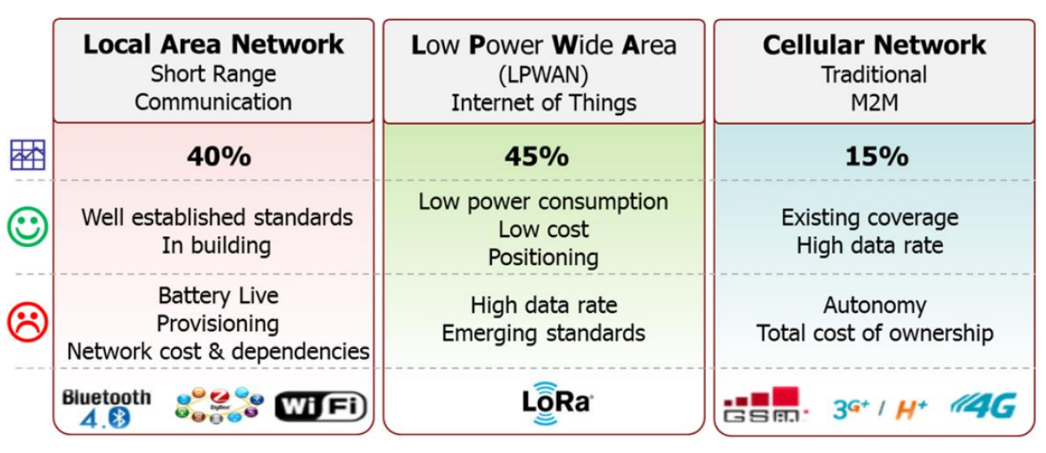

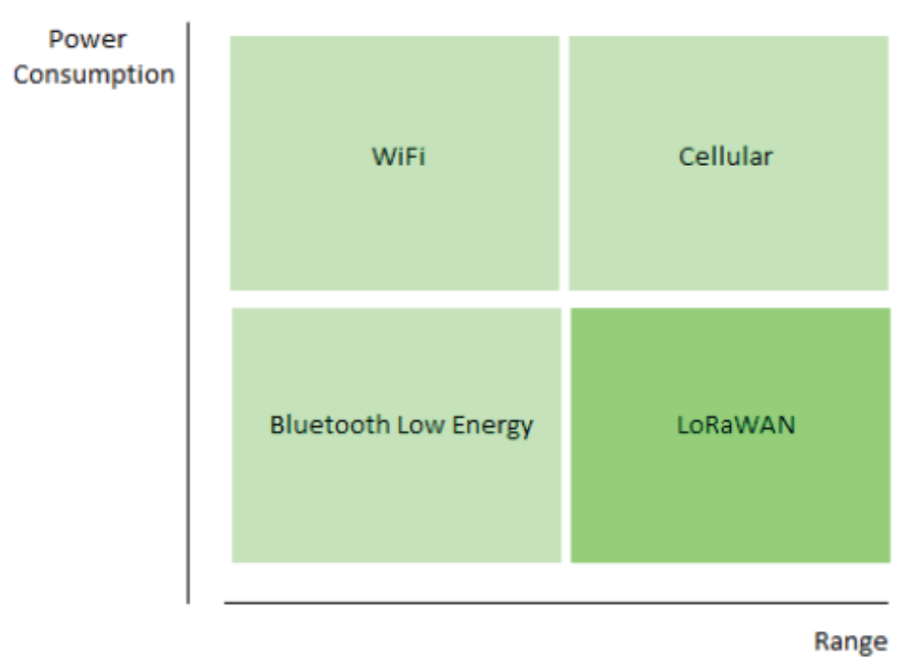

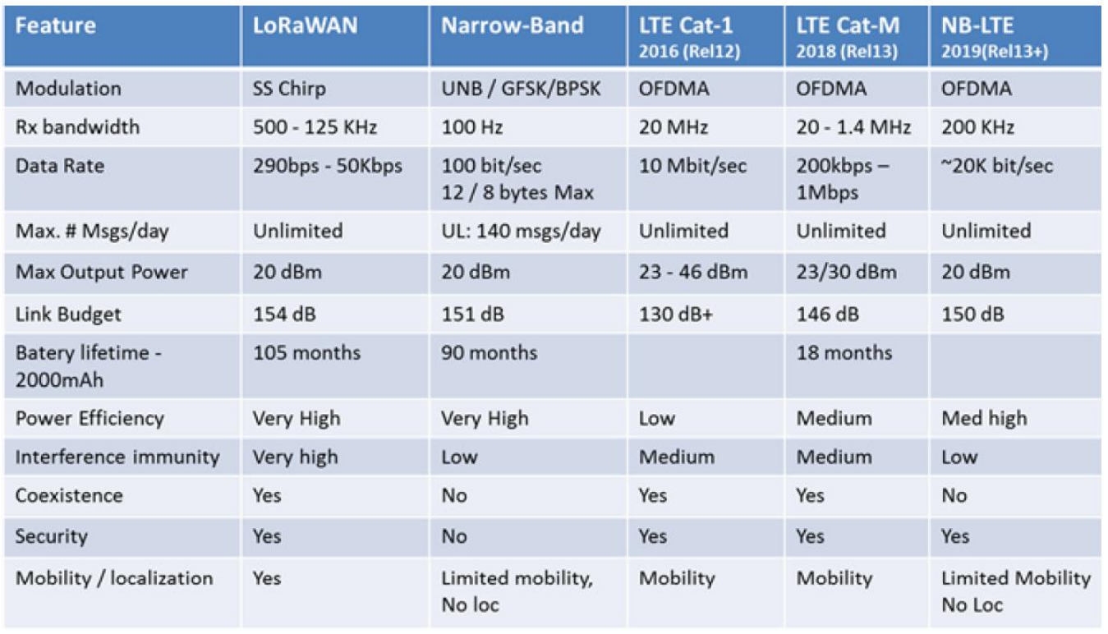

## Critical Factors

Based on the above description, there are a few factors that are critical to LPWAN:

* Network Architecture
* Communication Range
* Battery Life
* Robustness against interference
* Network capacity (i.e. the maximum number of nodes in the network)
* Network security
* One-way vs two-way communication
* Variety of applications that can be served

## Architecture

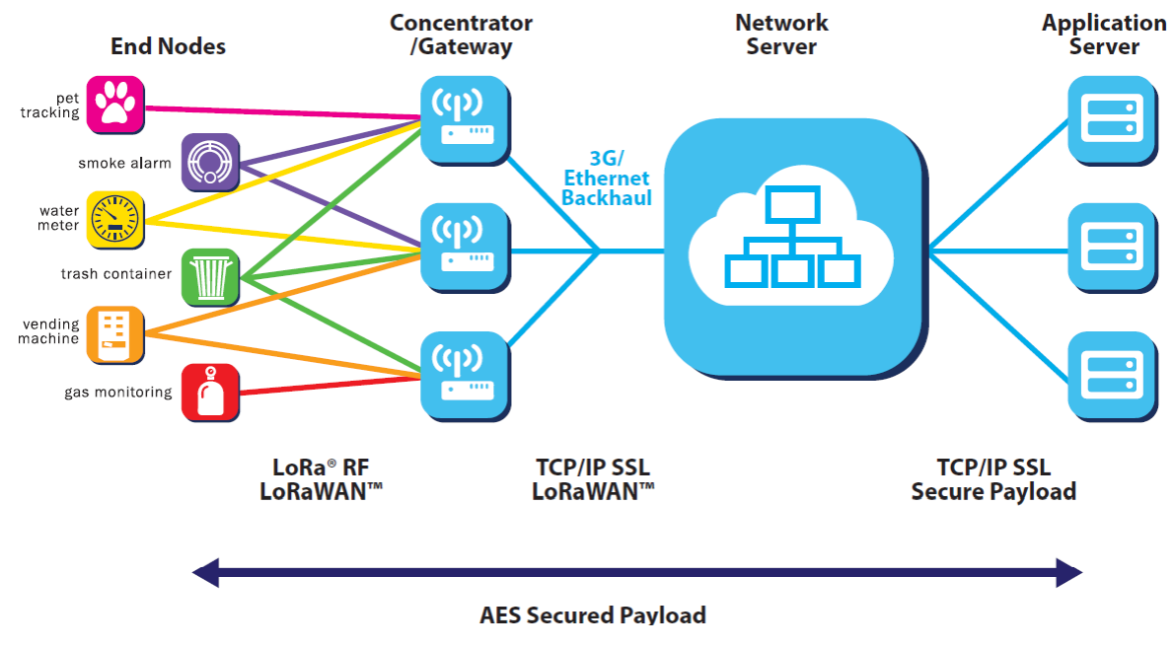

LoRaWAN is used in two places. Firstly, we have the long range communication over **radio frequency**. This is used to communicate between gateways and the actual end devices. Between the gateways and the server, the communication takes place over **3G** or **ethernet**. The rest functions in the same manner as the rest of the internet.

## Device Classes

LoRa supports three classes of devices:

* **Class A** – These are battery-powered sensors, the most energy-efficient devices. LoRa must be supported by all the devices, and the devices can only be communicated with after they make a transmission.
* **Class B** – These are battery-powered actuators (gateways). They are pretty energy efficient and the downlink is controlled. Communication takes place in slots, synchronized by a beacon.
* **Class C** – These are main-powered actuators. Since they do not have power issues, they can afford to listen continuously. There is no delay in downlink communication.

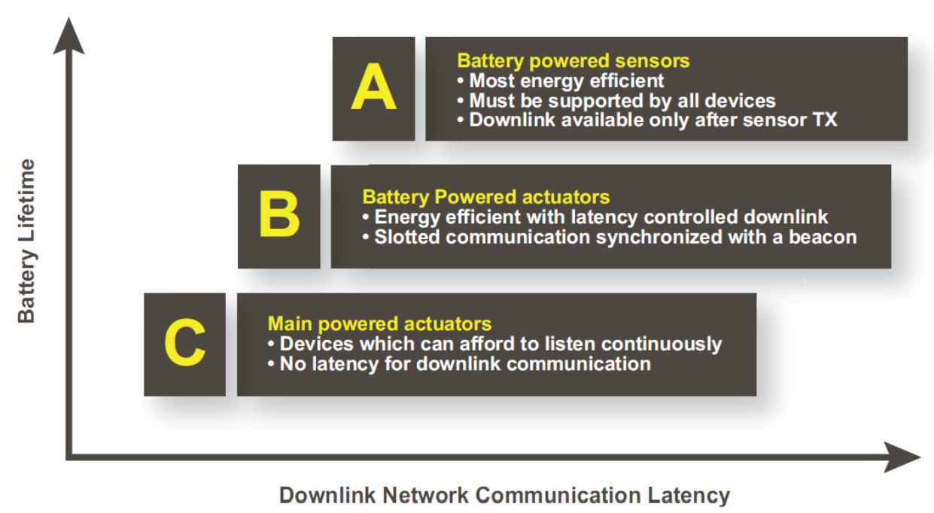

## Advantages

* **Long Range** – The distance that can be covered by LoRa is more than of cellular. It also has deep indoor coverage and uses the star topology.
* **Huge Lifetime** – Since LoRa is optimized for low-power devices, the battery life of devices using LoRa is 10 – 20 years, which is 10 times that of devices using cellular technology.
* **Multiple Users** – LoRa can support multiple clients simultaneously, meaning it is a high-capacity public network.
* **Low Cost** – LoRa requires minimal infrastructure, and the end devices are also cheap. The software used by LoRa is open-source.